**Readme**

1. **Optuna_model.ipynb**

**Optimal hyperparameters (layers/number of neurons per layer).**

1. **Modified the parameters.**

* xxx_file_path - The path of training data (*.csv).

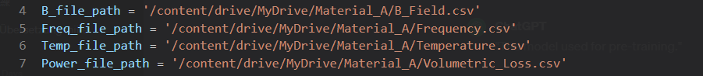

1. **Run. The best hyperparameters will be displayed as below.**

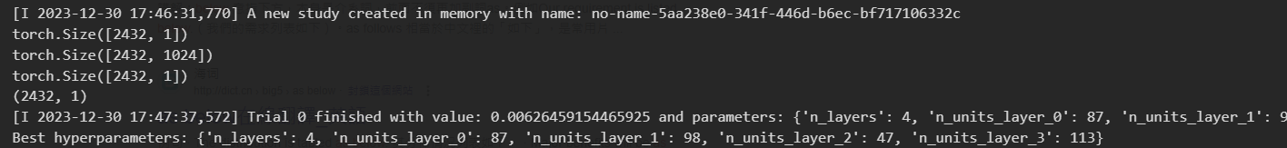

1. **Optuna_hyperparameters**

**Optimal hyperparameters (decay per epoch / decay ratio).**

* 1. **Modified the parameters.**
     + xxx_file_path - The path of training data (*.csv).



* 1. **Run. The best hyperparameters will be displayed as below.**

